When I was 14
In 2009, I had a wonderful experience, but I wasn't completely sure about its meaning then. When it happened, I was 14, still just a boy. I was the subject of the physical exam, which was good then, regarding my health, whilst today reminds me on some of my views and it gives me clear picture on my love for the prepuce.
Although I was a bit nervous that cold morning, everything went well. In the examination room, only doctor, a man, and myself were present. Very soon after I entered, I removed my clothes -- except the briefs -- and the examination was performed. The last part was about my genitals, when the doctor told me, "It's time for the genital examination". Being quite excited, I removed my underwear and asked, "Should I retract?", which was done then, and I was really naked before the doctor, exposing my glans, whilst the doctor was checking my testicles. Since everything was good, I put my clothes, being very satisfied.
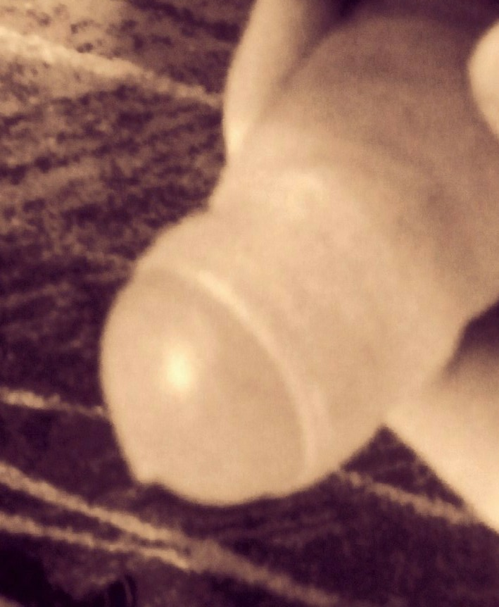
The foreskin should be preserved, since it's valuable for the glans protection and sexual pleasure, whilst the proper care should be given to the boy, so that he would learn about foreskin's importance and roles.

